This summary of key points in Local Transport Note 01/08 has been produced by PRIAN, the Public Realm Information and Advice Network: a not for profit organisation supporting individuals, professional bodies and government in improving the public realm. The aim is to provide a straight summary of the document rather than an interpretation.

LTN 01/08 is published by the Department for Transport. It is available from the Stationary Office
http://www.tsoshop.co.uk/bookstore.asp?Action=Book&ProductId=011552942X Price £22
People involved in public realm design and management design in the UK are strongly encouraged to buy a copy.

Good design principles
Difficulties with the design and delivery process include
- over-cautious and conservative approach,
- lack of collaborative design,
- the need to recognise place in the design process
- need to prioritise pedestrians in the movement hierarchy.
Flexibility - Designers should take full advantage of flexibility within the regulations
- avoid belt and braces designs
- neither good traffic management or good streetscape design are helped by over-provision and clutter
Wider picture – don’t focus on single issues – make balanced judgements that cover function and aesthetics.

Key themes in the Design Delivery Process
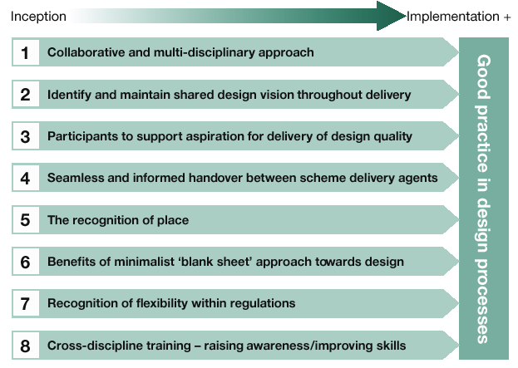
A single project, broken into separate programmes, budgets and timescales will be unsatisfactory unless coordinated over the long-term. Collaborative working is important.

Design context
The context includes general policies such as sustainability, inclusive communities, disability policies, personal security, Best Value, community engagement, and so on.

There have been a number of documents published in recent years that set a design context including:
Manual for Streets (DfT 2007)
Inclusive Mobility: A guide to Best Practice on Access to Pedestrian Transport Infrastructure (DfT 2004)
Better Streets, Better Places (ODPM 2003)

Key Points
- Good scheme design must meet functional and aesthetic objectives.
- ‘Less is more ’ should be a guiding principle of good scheme design.
- Practitioners need to be aware of the status and function of guidance documents and regulations.
- Good practice can be achieved within the regulations.
- It is important not to focus on single issues: look at the bigger picture.

Initiating a scheme
Streetscape issues should be considered for all traffic management schemes. The weighting given will depend on the size and type of scheme and on the location. The relative importance of particular streets/roads in terms of place and movement functions should inform subsequent design choices, and this can be determined using a place and movement matrix, reference to which has been made in Manual for Streets (DfT,2007).

Even for the smaller single-issue designs, such as access control measures, the designer is responsible for ensuring that full consideration is given to how the scheme fits in with its environment.

- Have a vision (reflecting existing council policies)

- Establish the scheme’s purpose – what does the scheme need to do?

Keep the design focussed on the Vision and Purpose - don’t let the scheme lose its integrity as it passes between one specialism to the next, or from design to implementation, and subsequent maintenance. Think about having a “design champion” to keep the design focussed on the original Vision and Purpose. The design champion can be a officer on the council or a councillor.

Good design performs better and can cost less in materials and maintenance. Attractive streetscapes increase the value of property, and commercial rental values (CABE Are the Streets Paved with Gold 2007).

Project brief – is important in large schemes and needs to be thorough, and cover both function and aesthetics, not just a single issue such as addressing road safety. Don’t leave things to interpretation: you will get what you ask for, so specify what you want. The brief should be developed by all concerned departments within the authority. It may cover:
- Vision and purpose -
- Design team capability required
- Design techniques required to be used in producing the design
- Funding available, Timescale required
- Policy and regulation context – including local design guides etc.
- Audit - function audit can, and streetscape audit should be included in the brief.

Link the funding to the Scheme Vision and Purpose If there is insufficient cash to fulfil the vision, do the scheme in stages; don’t compromise on quality,

Project Team Skills - must match the scheme: including urban design skills and other skills as required. It is best if the team works from one office.

Project management – the project manager’s role is to ensure the project to achieves the Vision and Purpose. Project managers must beware focussing on their particular professional perspective, if they have one!

Preparing the design
Starting point: Don’t use standards as a starting point- use the Vision and Purpose
See what regulations apply and what the flexibility is – use your judgement. Understand the difference between those things that have to be observed and those that don’t
“Designers are expected to use their professional judgement when designing schemes,” and not over-rely on guidance.
Use the “less is more” principle when it comes to design

Signs lines and markings –
- Some are necessary to give Traffic Orders legal effect
- But many are not required, or serve no useful function.
- Less driver certainty can lead to lower speed and greater safety
- If signs are needed, they should be installed in the way prescribed by the Traffic Signs and General Directions (2002)
  - Size – should reflect circumstance.
  - Location – consider mounting on walls or existing posts
- Sign and Marking Audits – can help reduce clutter.

Checklists - Sometimes it can help to use a checklist to aid an on-site assessment of the streetscene, or the evaluation of alternative designs.
Negative points– eg clutter, markings
Positive points– eg attractive buildings, quality materials
See Appendix A of the LTN for a comprehensive list

Recognise place – in all design projects
Design in 3D – to get a better impression of what the street will look like from the pedestrian perspective. Methods include sketches, simple axonometric drawings, or computer based visualisations
- a “blank-sheet” approach is a useful method of achieving clutter free design.
- Self-explaining roads is an important concept. –
NB photos realisations are sometimes interpreted by the public to mean that the scheme is a “done deal”

Quality audits – can be included in the brief, to be carried out for the duration of the project. They can be monitored by the Design Champion. There are many different approaches. The Road Safety Audit is part of that process: its findings are not mandatory, and are there to be balanced with wider issues, including the scheme’s Vision and Purpose.
Consider adopting a programme of quality audits for traffic management schemes (including streetscape) and revisiting sites periodically.

Implementing the design, monitoring and maintenance
Implementation
Design integrity can be lost as in the handover between design and implementation. Things that can go wrong include:
- Specified materials are not available
- Designs are wrongly interpreted or ad-hoc design changes are made
- Site-supervision is inadequate and workmanship is sub-standard
Involving the construction team early in design discussions can help avoid these problems. The client should retain responsibility for quality. Prepare detailed design drawings before implementation begins. Avoid the draw as you go approach.

Monitor the scheme
Quantitative monitoring – such as speeds, flows
Qualitative monitoring – public attitude surveys, behaviour of users eg using video monitoring
Monitor contractor and consultant performance
This helps lessons to be learned.

Maintenance
Consider maintenance costs as part of design. Many good schemes are let down by lack of maintenance.
Quality maintenance is required, using the right materials, installed in the right way. Include any special materials in the Street Works Register.
Management of the scheme needs to be considered too: undertake regular streetscape audits to keep maintenance quality high.

Training
Practitioners need to be aware of both functional and aesthetic perspectives. Find out what skills are needed by those involved in design and tailor training to the individual’s interests and abilities.

Raise awareness of the importance of streetscape among designers, and ideally all stakeholders including councillors and contractors. Streetscape audits are a way of doing this.

Skills training can cover:
- In the workplace eg staff mentoring, cross-discipline training to aid collaborative working
- External training including short courses through to degrees.

Appendix
A: Checklist; B Design Process Checklist;
Appendix C: Drawing in 3D

